CHIP690 mProject 5 Yannick Apedo

|  |  |  |  |  |
| --- | --- | --- | --- | --- |
| *Variables entered* | *B* | SE *B* | Cumulative *R2* | Δ*R2* |
| Step 1 |  |  |  |  |
| Tenure | -0.60 | .069 |  |  |
| Gender | .001 | .000 | .021 | .021 |
| *F*(2, 274) = 2.87 |  |  |  |  |
| Step 2 |  |  |  |  |
| LMX | .144 | .00 | .068 | .048 |
| *F*(3, 273) =6.666 |  |  |  |  |
| Step 3 |  |  |  |  |
| LMX2 | .124 | .038 | .101 | .033 |
| *F*(4, 272) =7.638 |  |  |  |  |
| Notes: * *p* < .05. *B* is the unstandardized coefficient; *SE B* is the standard error of B. LMX = Leader-Member Exchange. | | | | |

Quadratic function including points and fit line:

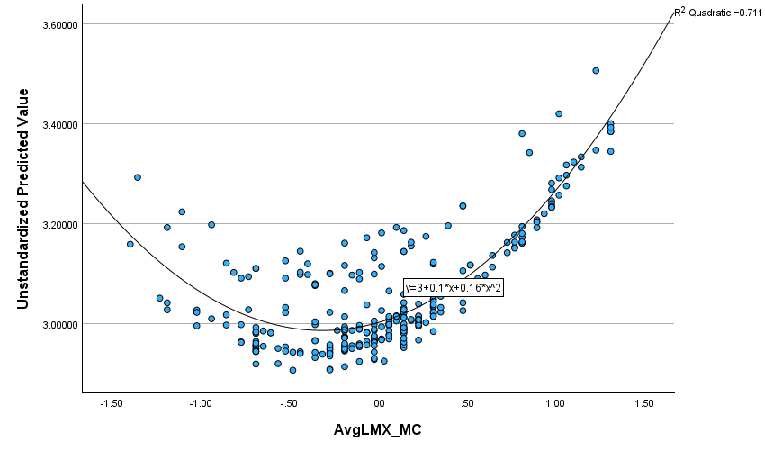

We ran a polynomial regression analysis to examine the quadratic effect of levels of perceived leader member exchange (LMX) on psychological well-being. Using gender and tenure as control variables, we wanted to see if these specific variables could play a role or impact results if not statistically controlled. First, squared terms were created from the centered variables. In the first step, the control variables of organizational tenure and gender were entered. We entered the linear LMX term in the second step, and the squared LMX term in the third step.

The results of the polynomial regression are shown in the first table. With step 1, tenure was actually shown to negatively and significantly relation to well-being, and oppositely for gender. When accounting for LMX and LMX squared for steps 2 and 3, we found them to be positively and significantly related to psychological well-being.

In the graph itself uses the predicted values of psychological well-being from the full regression equation and plotting them against LMX. Well-being increased as LMX quality increased.